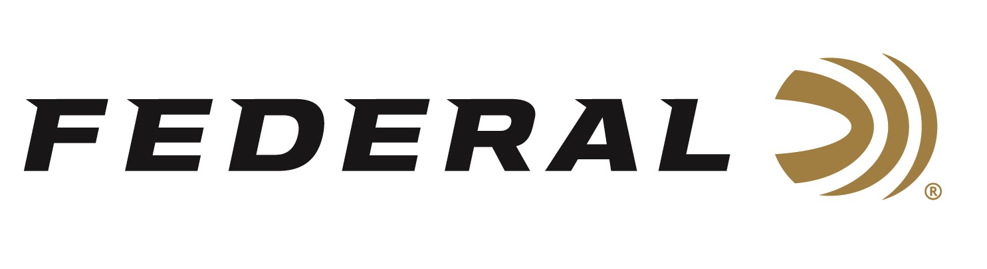

FOR IMMEDIATE RELEASE

Federal’s Derrick Mein Concludes 2025 NSCA Season on the Medal Stand

ANOKA, Minnesota – October 28, 2025 – Federal Ammunition congratulates Derrick Mein on his Main Event success at the 2025 NSCA Sporting Clays National Championships. Mein, a two-time Olympian in Men’s Trap, finished the Sporting Clays Main Event in the Runner-Up position.

The championships were held from October 18 to October 26, 2025, at the National Shooting Complex in San Antonio, Texas, with more than 1970 shooters vying for the Main Event championship. In all, 2,573 shooters competed at this year’s National Sporting Clays Championships.

“We congratulate Derrick Mein on his performance at this year’s NSCA Sporting Clays Nationals,” says Jason Nash, Vice President of Marketing for Federal. “Derrick is a fierce competitor and an outstanding ambassador for Team Federal whether he is shooting Men’s Trap on the world stage or at a NSCA Regional or National competition,” continued Nash.

In the Senior Super Veteran category, Team Federal’s Gary Greenway bested a field of 104 shooters to win the High Over All. Greenway also captured the Senior Super Veteran Super Sporting event title during the championships.

Mein loads his shotgun with Federal’s Gold Medal Paper shotshells when competing at NSCA events. With an exclusive paper hull design, high-antimony lead shot, and a two-piece wad that delivers more uniform patterns, Mein, like others, trusts in the gold standard set by Federal’s Gold Medal Paper shotshells.

Federal Ammunition products are available at dealers nationwide and online. For more information on all Federal products and to sign up to receive notifications about new product availability, rebate promotions, and other brand news via email, visit www.federalpremium.com.

Press Release Contact: JJ Reich
Senior Manager – Press Relations
E-mail: media@tkghunt.com

About Federal Ammunition
Federal, headquartered in Anoka, MN, is an ammunition brand of The Kinetic Group, owned by CSG, a globally diversified industrial group based in Prague, Czech Republic. Since 1922, Federal has been a leader in ammunition innovation, delivering high-quality sporting and hunting products to shooters worldwide. With a commitment to conservation and the outdoor community, Federal continues to manufacture industry-leading ammunition that enhances the shooting experience while supporting outdoor traditions.

